Project: Module 9: Assignment
Course: Capstone in Software Development
Description: Test Plans for Module 9
Date: 08/06/2026
To complete the test case plan, fill out the information for Project, Course, Description and Date in the header below.

Test 1 | Attractions Page Displays Correctly
 | Test Objective:  Verify that the Attractions Page properly displays. | Developer: Jackson Webster  Date tested: 8/7/2026 | Peer tester: Kimberly Orozco  Date tested: 8/7/2026
Step | Action | Expected results: | Developer pass/fail | Tester pass/fail
1 | Open the Attractions page from the landing page. | Attractions page should load when clicked on the navigation bar. | Yes
2 | Refresh the page | Page should reload with no errors. | Yes
3 | Verify that all information along with its images are displayed. | All information and its images should be displayed. | Yes | 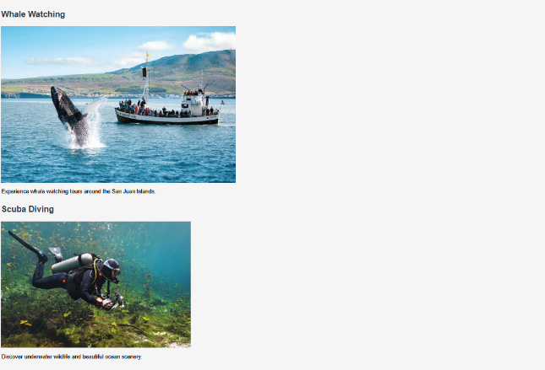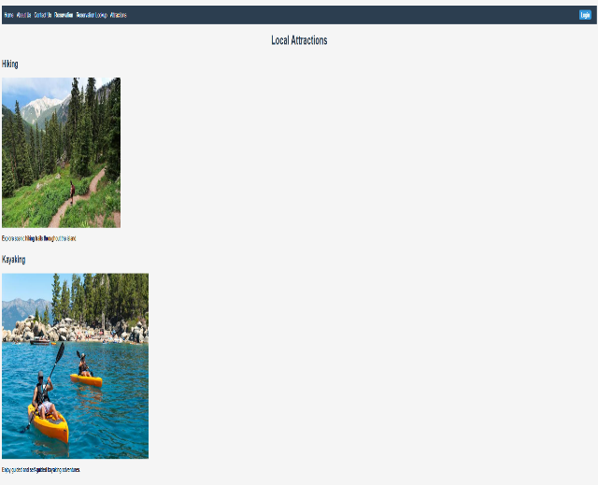
Comments | The Attractions page loaded successfully from the navigation bar. All text and images displayed correctly, and the page refreshed without any errors. The page functioned as expected and met all test requirements.

Test 2
Description: Attractions Navigation and Content
Test Objective: Verify that the Attractions page can be opened from the navigation menu and that all page content loads correctly.
Developer | Jackson Webster
Date Tested | 8/7/2026

Step | Action | Expected Results | Developer Pass/Fail | Tester Pass/Fail
1 | Open the Moffat Bay home page. | Home page opens successfully. | Yes
2 | Click the Attractions link. | Attractions page loads without errors. | Yes
3 | Check attraction names and descriptions. | All text is displayed correctly. | Yes
4 | Check attraction images. | All images load with no broken links. | Yes | 
5 | Refresh the page. | Page reloads and content remains visible. | Yes

Comments
The Attractions page navigation worked correctly from the home page. All attraction names, descriptions, and images loaded properly with no broken links or display issues. Refreshing the page did not affect the content, and all expected functionality passed successfully.

